# **Generation of Marsh Points - Feb2017**

1. Merge Old and New TMI into single file. Dissolve—DO NOT create multipart features (just for Taskinas – just start with the New TMI) Taskinas_NewTMI convert this one to LIne
2. Convert merged TMI into line feature.
3. Buffer line feature by 15m, both sides (dissolve type: ALL) /flat
4. Erase the part of the buffer that overlaps the water using the water layer. (N:\Modelling_Intertidal_Habitats\Data\GIS\base_files.gdb\YR_Water_July_2015_RI – Analysis tool/overlay/erase-
5. Generate a 100m (or 50m)(or appropriate size) fishnet using the Create Fishnet tool in Data Management
6. Use the Command geom.splitpolysbylines in GME to split the buffer polygons where they intersect the lines. (in: is the buffer)/ line is the “fishnet”/ Single part:TRUE - **REMEMBER TO EXPLODE!!!**
7. Add a field called “Angle” to the split shapefile (Float)
8. Use the “Calculate Polygon Main Angle” tool in ArcMap to get the main angle. Use Rotation Method = Geographic. Angle field = Angle (Cartography Tools/Cartographic Refinement/)
9. Add fields called “XDIST” and “YDIST” to the split shapefile. Use the field calculator to make the XDIST = 5, and the YDIST = 1. (these numbers are for the long-shore and cross-shore resolutions)
10. Erase the buffered area from the Merged TMI file. Repeat step 9 on the erased file, changing XDIST and YDIST value to 30 (this is the inner part of the marsh).

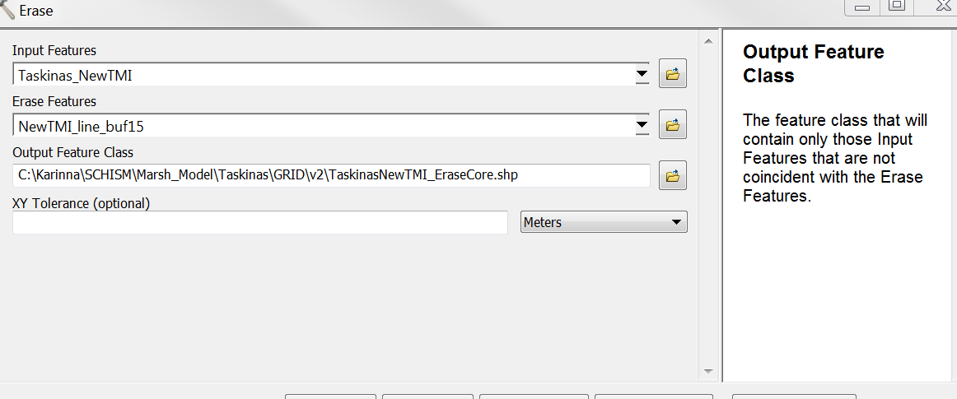

1. Merge the Split Buffered shapefile and the Erased TMI file.
2. Use the genregularptsinpolys command in GME to generate the grid points. Set the XDIST and YDIST fields accordingly. The optional [rot] argument should be your Angle field. The output will be the grid points.

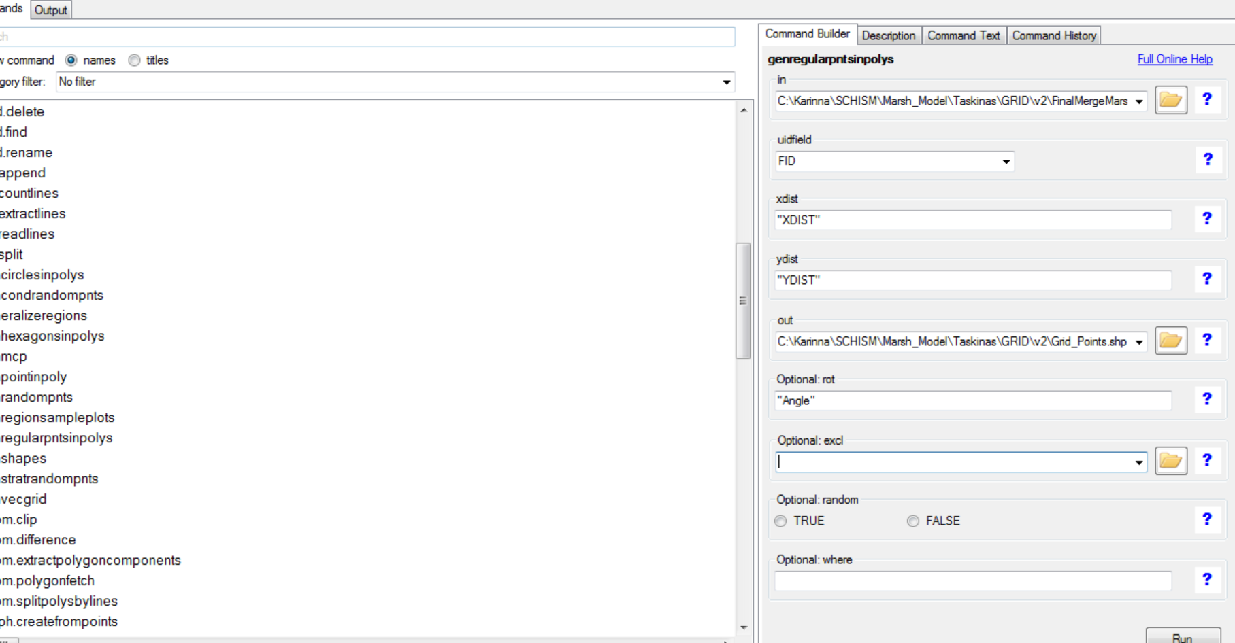

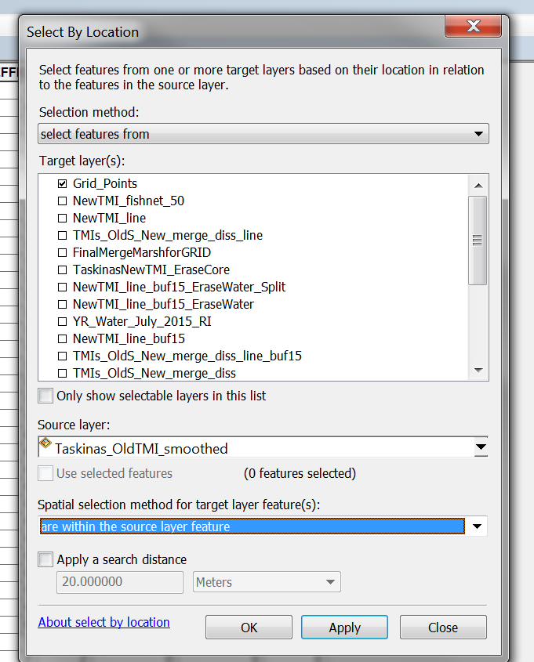

1. **If the shapefile is a point file:** XY coordinates need to be added. Then the attribute table needs to be exported as a .dbf. That table can be opened in Excel. Use the “Open” command and after selecting the file, we need to make sure to select the option for the file format “dBase files”. After the file is opened in Excel, we can save it as text file (.txt) Text (tab delimited)

***OR:***

1. Convert the grid points to an ascii file.

(spatial statistics/utilities/Export Feature attribute to ASCII

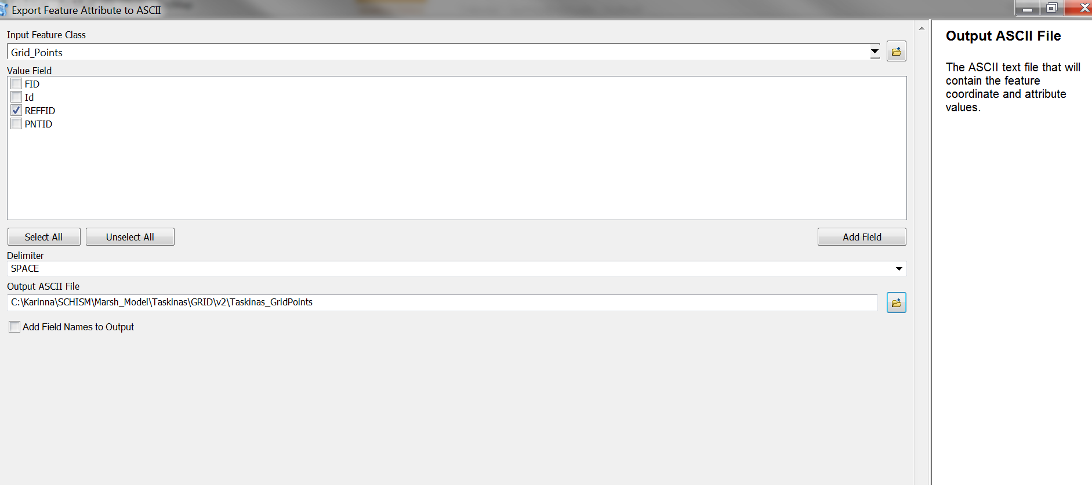

FINAL FILE FOR TASKINAS CREEK:

C:\Karinna\SCHISM\Marsh_Model\Taskinas\GRID\v2\ Taskinas_GridPts (text file)